**Name : Sree Santhikrishna S**

**Reg no : 727721eucs149**

**DAY 9**

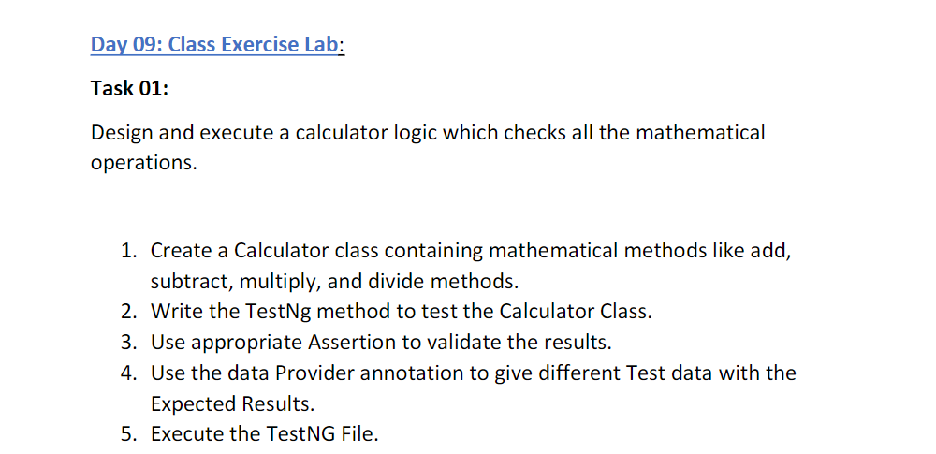

**CODE :**

package test.Day9;

import org.testng.annotations.Test;

import org.testng.annotations.DataProvider;

public class CE_1 {

@Test(dataProvider = "dp", priority=1)

public void add(Integer n1, Integer n2) {

System.out.println("Add : "+ (n1+n2));

}

@Test(dataProvider = "dp", priority=2)

public void sub(Integer n1, Integer n2) {

System.out.println("Sub : "+ (n1-n2));

}

@Test(dataProvider = "dp", priority=3)

public void mul(Integer n1, Integer n2) {

System.out.println("Multiply : "+ n1*n2);

}

@Test(dataProvider = "dp", priority=4)

public void div(Integer n1, Integer n2) {

System.out.println("Div : "+ n1/n2);

}

@DataProvider

public Object[][] dp() {

return new Object[][] {

new Object[] { 18, 26 },

new Object[] { 30, 1 },

};

}

}

**OUTPUT :**

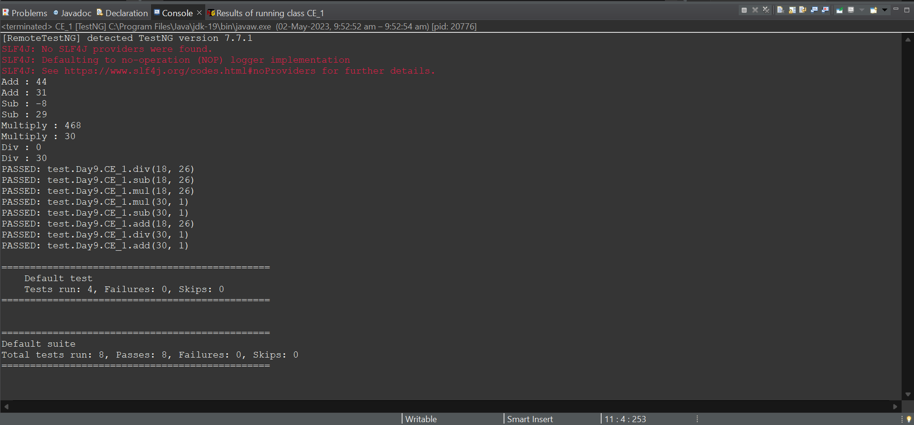

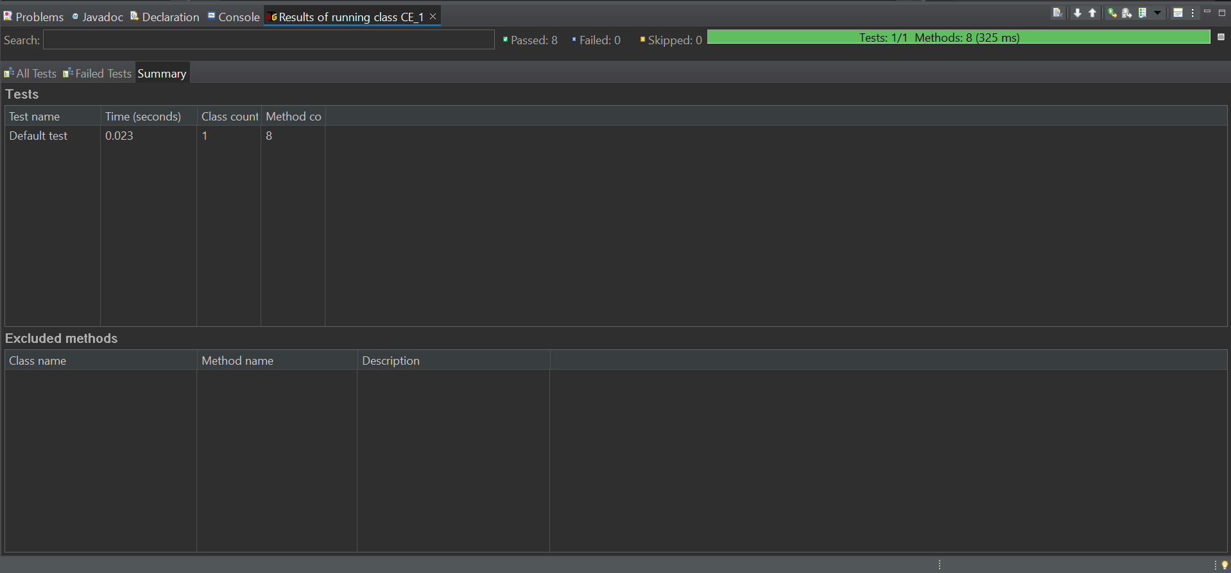

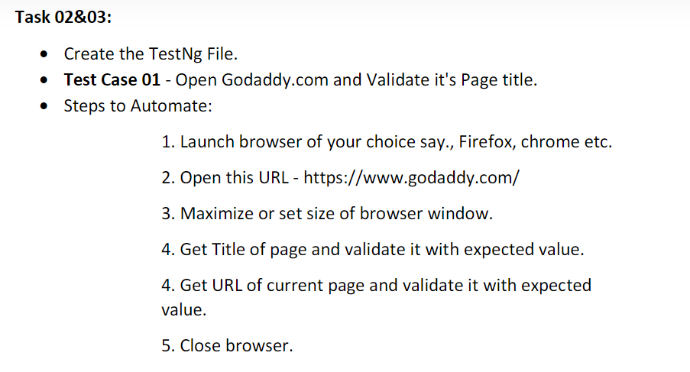

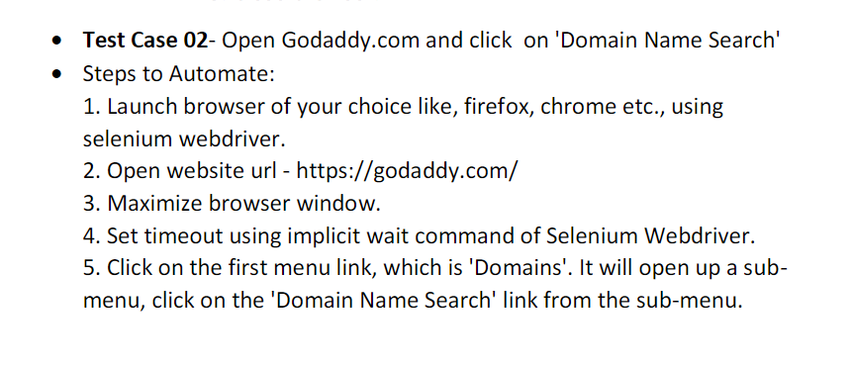

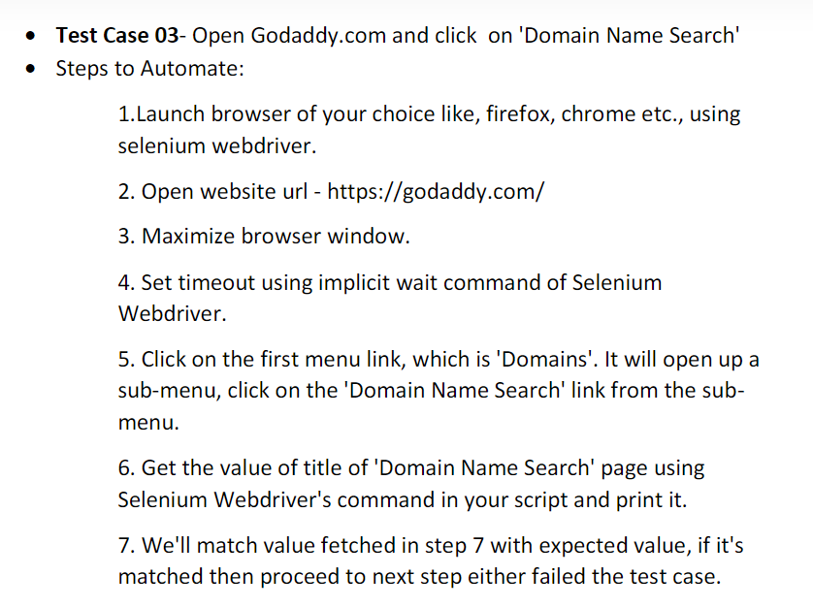

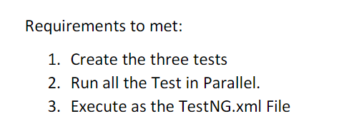

**CODE :**

package test.Day9;

import org.openqa.selenium.By;

import org.openqa.selenium.WebDriver;

import org.openqa.selenium.chrome.ChromeDriver;

import org.openqa.selenium.chrome.ChromeOptions;

import org.testng.Assert;

import org.testng.annotations.Test;

import io.github.bonigarcia.wdm.WebDriverManager;

public class CE_2_3 {

WebDriver driver;

@Test (groups="SmokeTest")

public void testCase1() {

ChromeOptions co = new ChromeOptions();

co.addArguments("--remote-allow-orginis=*");

WebDriverManager.chromedriver().setup();

driver = new ChromeDriver();

driver.get("https://www.godaddy.com/en-in");

driver.manage().window().maximize();

String url = driver.getCurrentUrl();

Assert.assertEquals(url, "https://www.godaddy.com/en-in");

String title= driver.getTitle();

Assert.assertEquals(title, "Domain Names, Websites, Hosting & Online Marketing Tools - GoDaddy IN");

driver.close();

}

@Test (groups="RegressionTestCase")

public void testCase2() throws InterruptedException {

ChromeOptions co = new ChromeOptions();

co.addArguments("--remote-allow-orginis=*");

WebDriverManager.chromedriver().setup();

driver = new ChromeDriver();

driver.get("https://www.godaddy.com/en-in");

driver.manage().window().maximize();

// driver.manage().timeouts().implicitlyWait(10, TimeUnit.SECONDS);

Thread.sleep(3000);

driver.findElement(By.xpath("/html/body/header/div/section/div/div[1]/nav/button/span")).click();

Thread.sleep(3000);

driver.findElement(By.xpath("/html/body/header/div/section/div/div[1]/nav/div[2]/div[1]/ul/li[1]/button")).click();

Thread.sleep(3000);

driver.findElement(By.linkText("Domain Name Search")).click();;

driver.close();

}

@Test

public void testCase3() throws InterruptedException {

ChromeOptions co = new ChromeOptions();

co.addArguments("--remote-allow-orginis=*");

WebDriverManager.chromedriver().setup();

driver = new ChromeDriver();

driver.get("https://www.godaddy.com/en-in");

driver.manage().window().maximize();

// driver.manage().timeouts().implicitlyWait(10, TimeUnit.SECONDS);

Thread.sleep(3000);

driver.findElement(By.xpath("/html/body/header/div/section/div/div[1]/nav/button/span")).click();

Thread.sleep(3000);

driver.findElement(By.xpath("/html/body/header/div/section/div/div[1]/nav/div[2]/div[1]/ul/li[1]/button")).click();

Thread.sleep(3000);

driver.findElement(By.linkText("Domain Name Search")).click();

Thread.sleep(3000);

String title= driver.getTitle();

Assert.assertEquals(title, "GoDaddy Domain Search - Buy and Register Available Domain Names");

System.out.println(title);

Thread.sleep(3000);

driver.close();

}

}

**Xml file :**

<?xml version="1.0" encoding="UTF-8"?>

<!DOCTYPE suite SYSTEM "https://testng.org/testng-1.0.dtd">

<suite name="Suite" parallel="methods">

<test thread-count="1" name="Test">

<classes>

<class name="test.Day9.CE_2_3"/>

</classes>

</test> <!-- Test -->

</suite> <!-- Suite -->

**OUTPUT :**

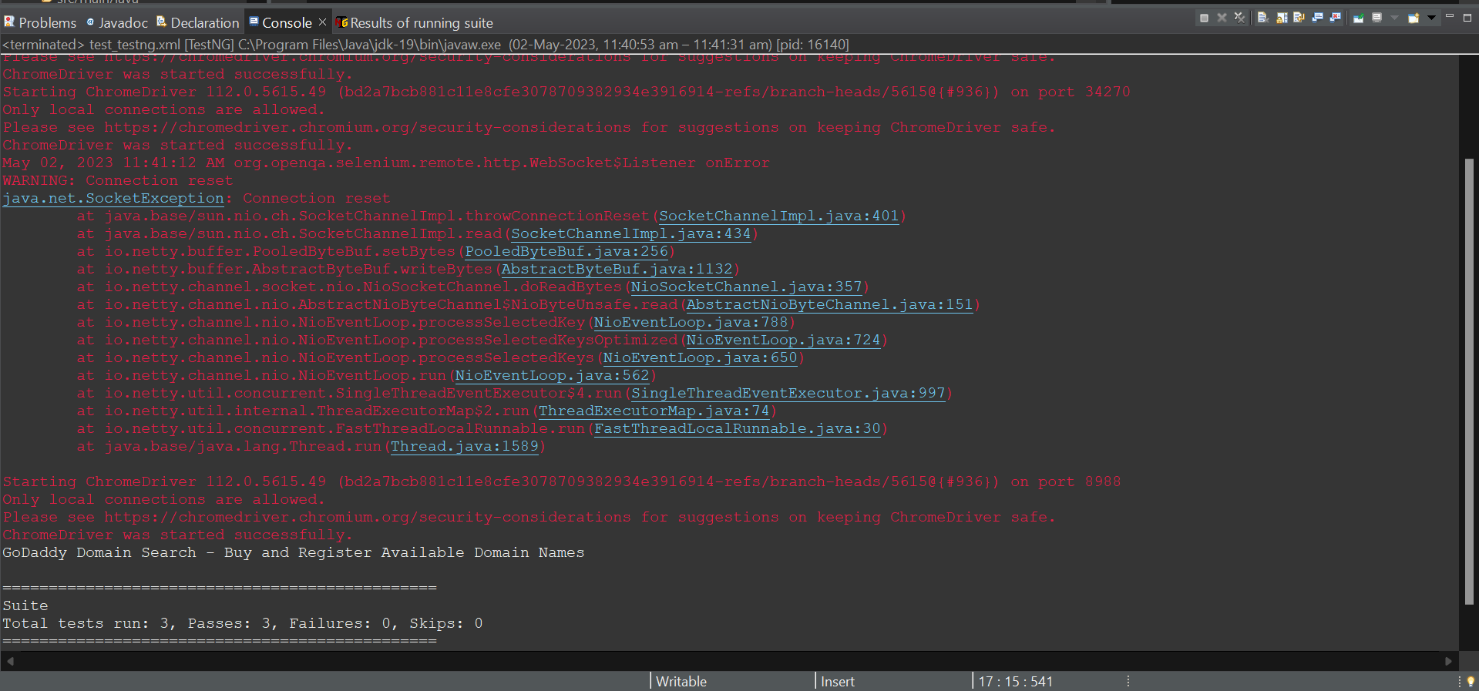

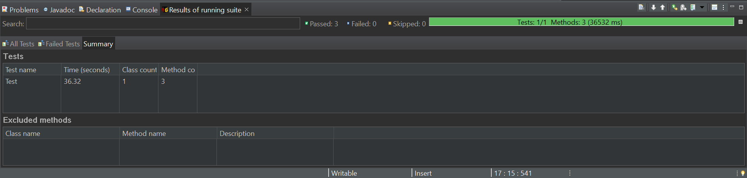

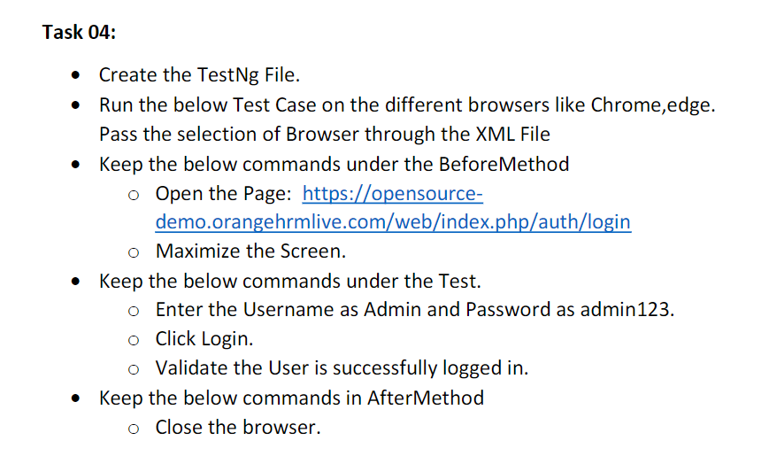

**CODE :**

package test.Day9;

import org.testng.annotations.Test;

import io.github.bonigarcia.wdm.WebDriverManager;

import org.testng.annotations.BeforeMethod;

import org.testng.annotations.Parameters;

import org.openqa.selenium.By;

import org.openqa.selenium.WebDriver;

import org.openqa.selenium.chrome.ChromeDriver;

import org.openqa.selenium.chrome.ChromeOptions;

import org.openqa.selenium.edge.EdgeDriver;

import org.openqa.selenium.edge.EdgeOptions;

import org.testng.Assert;

import org.testng.annotations.AfterMethod;

public class CE_4 {

WebDriver driver;

@Test

public void f() throws InterruptedException {

Thread.sleep(3000);

driver.findElement(By.xpath("/html/body/div/div[1]/div/div[1]/div/div[2]/div[2]/form/div[1]/div/div[2]/input")).sendKeys("Admin");

driver.findElement(By.xpath("/html/body/div/div[1]/div/div[1]/div/div[2]/div[2]/form/div[2]/div/div[2]/input")).sendKeys("admin123");

driver.findElement(By.xpath("/html/body/div/div[1]/div/div[1]/div/div[2]/div[2]/form/div[3]/button")).click();

Thread.sleep(3000);

String str=driver.findElement(By.xpath("/html/body/div/div[1]/div[1]/header/div[1]/div[1]/span/h6")).getText();

Assert.assertEquals(str, "Dashboard");

}

@Parameters({"browser"})

@BeforeMethod

public void beforeMethod(String browser) {

if(browser.equals("chrome")) {

ChromeOptions co = new ChromeOptions();

co.addArguments("--remote-allow-orginis=*");

WebDriverManager.chromedriver().setup();

driver = new ChromeDriver();

driver.get("https://opensource-demo.orangehrmlive.com/web/index.php/auth/login");

driver.manage().window().maximize();

}

else if(browser.equals("edge")) {

EdgeOptions co = new EdgeOptions();

co.addArguments("--remote-allow-orginis=*");

WebDriverManager.edgedriver().setup();

driver = new EdgeDriver();

driver.get("https://opensource-demo.orangehrmlive.com/web/index.php/auth/login");

driver.manage().window().maximize();

}

}

@AfterMethod

public void afterMethod() {

driver.close();

}

}

**Xml file :**

<?xml version="1.0" encoding="UTF-8"?>

<suite parallel="false" name="Suite">

<test name="Test">

<parameter name="browser" value="edge"></parameter>

<classes>

<class name="test.Day9.CE_4"/>

</classes>

</test> <!-- Test -->

</suite> <!-- Suite -->

**OUTPUT :**

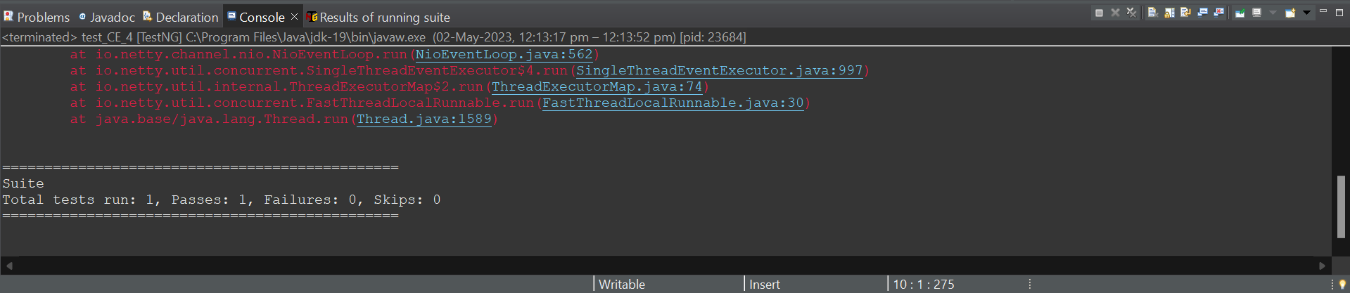

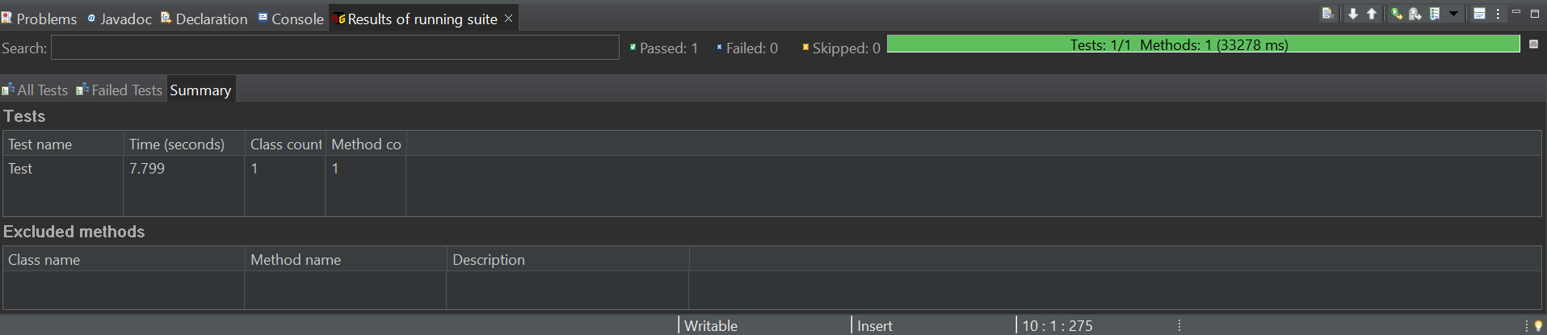

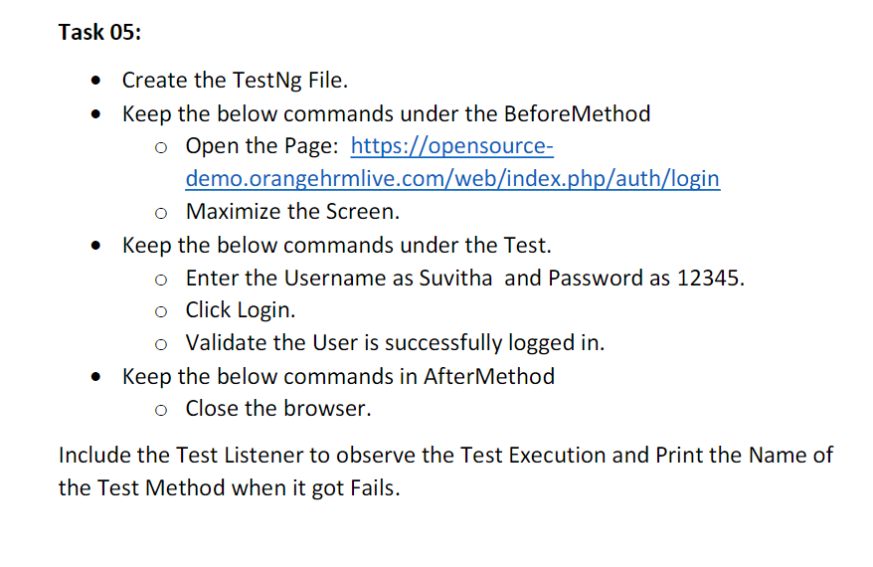

**CODE :**

package test.Day9;

import org.testng.annotations.Test;

import io.github.bonigarcia.wdm.WebDriverManager;

import org.testng.annotations.BeforeMethod;

import org.openqa.selenium.By;

import org.openqa.selenium.WebDriver;

import org.openqa.selenium.chrome.ChromeDriver;

import org.openqa.selenium.chrome.ChromeOptions;

import org.testng.Assert;

import org.testng.annotations.AfterMethod;

public class CE_5 {

WebDriver driver;

@Test

public void f() throws InterruptedException {

Thread.sleep(3000);

driver.findElement(By.xpath("/html/body/div/div[1]/div/div[1]/div/div[2]/div[2]/form/div[1]/div/div[2]/input")).sendKeys("Suvitha");

driver.findElement(By.xpath("/html/body/div/div[1]/div/div[1]/div/div[2]/div[2]/form/div[2]/div/div[2]/input")).sendKeys("12345");

driver.findElement(By.xpath("/html/body/div/div[1]/div/div[1]/div/div[2]/div[2]/form/div[3]/button")).click();

Thread.sleep(3000);

String str=driver.findElement(By.xpath("/html/body/div/div[1]/div[1]/header/div[1]/div[1]/span/h6")).getText();

Assert.assertEquals(str, "Dashboard");

}

@BeforeMethod

public void beforeMethod() {

ChromeOptions co = new ChromeOptions();

co.addArguments("--remote-allow-orginis=*");

WebDriverManager.chromedriver().setup();

driver = new ChromeDriver();

driver.get("https://opensource-demo.orangehrmlive.com/web/index.php/auth/login");

driver.manage().window().maximize();

}

@AfterMethod

public void afterMethod() {

driver.close();

}

}

**LISTENER CLASS :**

package test.Day9;

import org.testng.ITestContext;

import org.testng.ITestListener;

import org.testng.ITestResult;

public class listenerClass implements ITestListener {

public void onTestStart(ITestResult result) {

// TODO Auto-generated method stub

System.out.println(result.getName());

}

public void onTestSuccess(ITestResult result) {

// TODO Auto-generated method stub

System.out.println(result.getName());

}

public void onTestFailure(ITestResult result) {

// TODO Auto-generated method stub

System.out.println(result.getName());

}

public void onTestSkipped(ITestResult result) {

// TODO Auto-generated method stub

System.out.println(result.getName());

}

public void onTestFailedButWithinSuccessPercentage(ITestResult result) {

// TODO Auto-generated method stub

System.out.println(result.getName());

}

public void onTestFailedWithTimeout(ITestResult result) {

// TODO Auto-generated method stub

System.out.println(result.getName());

}

public void onStart(ITestContext context) {

// TODO Auto-generated method stub

System.out.println("onStart");

}

public void onFinish(ITestContext context) {

// TODO Auto-generated method stub

System.out.println("onFinish");

}

}

**Xml file :**

<?xml version="1.0" encoding="UTF-8"?>

<suite parallel="false" name="Suite">

<listeners>

<listener class-name="test.Day9.listenerClass"></listener>

</listeners>

<test name="Test">

<classes>

<class name="test.Day9.CE_5"/>

</classes>

</test> <!-- Test -->

</suite> <!-- Suite -->

**OUTPUT :**

